

2017 Burlingame Chamber Annual Meeting
January 13, 2017

Single Ticket Request

Event Details
The Annual Meeting Luncheon and Installation of Chamber Board of Directors will be held at the Hyatt Regency SFO, 1333 Bayshore Highway. The reception starts at 11:30 a.m., lunch will be served at noon and the keynote address will begin at 1:00 p.m. The program will end promptly at 1:30 p.m. Individual ticket cost is $90. Send checks payable to the Burlingame Chamber of Commerce, 417 California Drive, Burlingame, CA 94010. To purchase a table for your company, or for sponsorship information, contact the Chamber office at 650-344-1735.

This Year’s Keynote Speaker

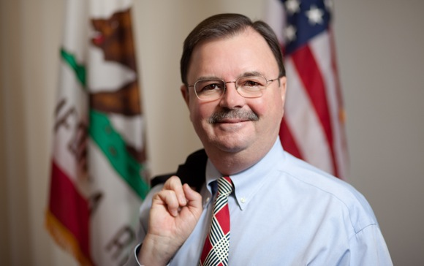
Rich Gordon, California State Assemblyman
Rich Gordon has spent his life in service to others first as a minister in the United Methodist Church and later in the nonprofit sector. He spent twenty-four years in elected office. He served as a member of the California State Assembly serving as Chair of the Rules Committee for three different Speakers. He saw 70% of the legislative ideas he pursued signed into law specifically in the areas of the environment, election law and transparency, and water policy. He also served for thirteen years on the San Mateo County Board of Supervisor, as a member of the San Mateo County Board of Education for five years and as a minister in the United Methodist Church. He was the founder and Executive Director of Youth and Family Assistance.

Reservation Form
Name_______________________________________
Title________________________________________ Affiliation___________________________________ Address____________________________________________________________ ___________________________________________________________________
No. Attending:________ at $90 per person ____________)
Total amount enclosed $________ List of guests attending, please print: ___________________________________________________________________ ___________________________________________________________________

